File No. 20-683
By Supervisors Czarnezki, Sumner, Shea, Goodwin Sr., and Wasserman

A RESOLUTION

Requesting the Department of Administrative Services Office of Performance, Strategy and Budget collaborate with the Office of the Comptroller and Department of Human Resources, to develop an informational report on the possibility of adopting the Dane County Wisconsin State Employee Healthcare Plan (WSEHP) Model in Milwaukee County to mitigate public employee healthcare cost inflation

WHEREAS, according to a July 2020 Brookings Institution article titled, “Reopening America: Creating a more equitable healthcare system”, based on Organisation for Economic Co-operation and Development (OECD) data, Americans pay significantly more for their healthcare compared to peoples in any other developed economy at approximately 17 percent of US gross domestic product, and that higher spending is wasteful as it yields poorer health outcomes on average; and

WHEREAS, healthcare costs continue to pose a significant burden on local governments across Wisconsin due to the necessity of appropriating more and more tax dollars and subsequently higher proportions of budgets toward employee and retiree health insurance, which poses a substantial roadblock for local governments to deliver the essential services citizens expect and deserve; and

WHEREAS, excessive healthcare inflation exacerbates the fiscal stress of Wisconsin’s local governments and Milwaukee County’s structural deficit, imposed by the State’s statutory local government finance regime, which Milwaukee County continues to address by seeking a fair deal partnership from the State to Move Forward MKE (File Nos. 18-944, 19-161, and 19-831); and

WHEREAS, Milwaukee County has previously made efforts to reduce healthcare costs by creating an employee wellness program which incentivizes better health outcomes and therefore reduces catastrophic cases, and negotiating contract changes with the County’s health insurance provider (File No. 18-944); and

WHEREAS, according to a joint University of Wisconsin – Madison and Community Advocates Public Policy Institute paper from 2014 titled, “The Dane Difference: Why Does Wisconsin’s Health Insurance Exchange for State Employees in Dane County Get Much Lower Premiums Than Its Exchanges in 71 Other Counties? What Lessons Can Policymakers Learn?” (heretofore attached in this file), determined through the use of regression analysis, in 2013 an individual plan in the Wisconsin State Employee Health Plan (WSEHP) was approximately $1,400 cheaper annually in Dane County, or 16 percent cheaper than the average in the remainder of Wisconsin; and a family plan was approximately $3,500 cheaper, also 16 percent lower; and

WHEREAS, these differences have existed for a long time, as illustrated by the following three figures from pages three to four of “The Dane Difference”:

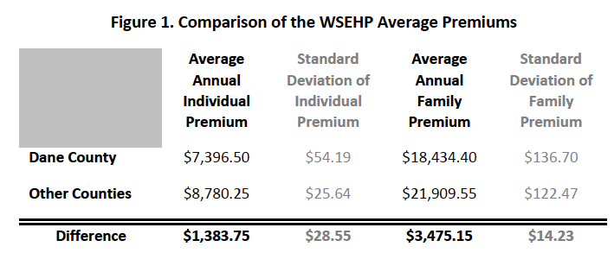

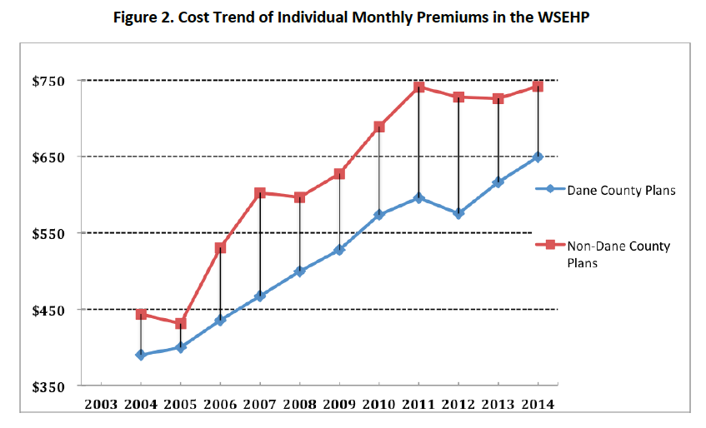
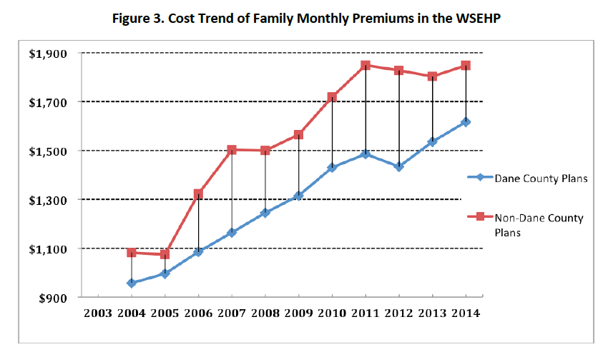
; and

WHEREAS, the capacity of the WSEHP to significantly mitigate rising employee health insurance costs in Dane County than in Wisconsin’s other 71 counties is not the result of differences between who is covered, but rather how Wisconsin’s health insurance program for State employees operates in Dane County versus the other 71 counties; and

WHEREAS, the specific reasons the “The Dane Difference” identified for why the WSEPH restrains employee health insurance costs in Dane County relative to all other Wisconsin counties were:

- The relatively large share (approximately half) of State employees, their spouses, and dependent children, in Dane County constituted a larger percentage of the county’s non-Medicaid/non-Medicare population compared to the small share such covered lives represented in Wisconsin’s other 71 counties

- The large number of high-quality healthcare plans (also integrated delivery systems) competing to provide health insurance in Dane County compared to fewer high-quality plans (also integrated delivery systems) in the other 71 counties

; and

WHEREAS, the WSEPH evaluation discussed in “The Dane Difference” suggests that all of the conditions which enable the WSEPH to do a superior job of constraining State employee health insurance costs in Dane County could possibly be met for government employees in the remaining Wisconsin counties if the following conditions present in Dane County were to apply in the remaining Wisconsin counties:

- Inclusion in a single purchasing pool of a very large percentage of the county’s population not enrolled in Medicaid or Medicare,

- A policy which WSEPH follows in all counties offering State employees a choice among competing health insurance plans, but clearly incentivizing employees to select the lowest cost plan(s) by requiring them to pay extra if employees opt to enroll in a more costly plan (this policy’s intent incentivizes lower premiums and improved quality, and therefore more competitive plans, in perpetuity),

- Offer employees included in the very large purchasing pool a significant number (three or four) of high-quality healthcare plans which optimally are integrated delivery systems,

; and

WHEREAS, the first and perhaps most critical of the aforementioned conditions – a purchasing pool with a very large share of a county’s population – unfortunately does not currently exist outside of Dane County, including Milwaukee County; and

WHEREAS, the Dane County WSEHP provides health insurance for approximately 25 percent of that county’s non-Medicaid/non-Medicare population, while WSEHP only provides health insurance for between 5 and 15 percent of the same population in the rest of the State, including Milwaukee County; and

WHEREAS, Milwaukee County can play a constructive role in constraining health insurance cost inflation for the County’s own employees and those of Milwaukee area municipalities, school districts, and special units of government by making the crucial step of leading in the replication of the Dane County WSEHP Model; now, therefore,

BE IT RESOLVED, Milwaukee County hereby requests the Department of Administrative Services Office of Performance, Strategy and Budget (DAS-PSB) works in conjunction with the Office of the Comptroller and the Department of Human Resources to study and develop an informational report which shall be reported to the County Board of Supervisors no later than the March 2021 Cycle, examining the possibility, efficacy, necessary steps to undertake, and fiscal impact of applying the conditions present in the WSEHP Dane County Model for the purpose of constraining cost inflation of employee health insurance, specifically:

- Inclusion a very large percentage of the county’s population not enrolled in Medicaid or Medicare in a single purchasing pool

- Offering public employees a choice among competing health insurance plans, but clearly incentivizing employees to select the lowest cost plan(s) by requiring them to pay extra if employees opt to enroll in a more costly plan

- Offer employees included in the very large purchasing pool a significant number (three or four) of high-quality healthcare plans which optimally are integrated delivery systems

; and

BE IT FURTHER RESOLVED, Milwaukee County requests the report include the total number of covered lives from Milwaukee County public employees, public employees of all 19 of its municipalities, all school districts, and special government units which provide health insurance, including the percentages these covered lives (based on residency) represented as a share of the non-Medicaid/non-Medicare population of Milwaukee County and any other county where employees and their families may reside; and

BE IT FURTHER RESOLVED, Milwaukee County requests the County Clerk provide a copy of the informational report to all members of the Intergovernmental Cooperation Council (ICC), all Milwaukee County school districts, and all special units of government in Milwaukee County.

