County of Milwaukee
Interoffice Communication

DATE: January 12, 2015

TO: Supervisor Peggy Romo West, Chairwoman, Committee on Health and Human Needs

FROM: Maria Ledger, Director, and Department of Family Care

SUBJECT: Information Only Report relative to Milwaukee County’s Living Wage Ordinance

The Milwaukee County Department of Family Care Managed Care Organization serves over 8,400 members who are elderly and/or have intellectual, developmental or physical disabilities. We do so under a contract with the Department of Health Services and a permit issued by the Office of the Commissioner of Insurance.
Milwaukee County is only one (1) of four (4) Long Term Care options available to individuals in Milwaukee County in need of assistance. Community Care Inc., iCare and IRIS, the State’s self-directed supports program, are also available in Milwaukee County.
The Department receives a capitated rate for every member served. The State sets that rate every year and using only those dollars provided, the Department must provide all of the services that a member needs.
The list of services the MCO can authorize is extensive and covers everything from diabetic supplies to transportation to nursing homes to in home care services and is included as Attachment A.
The Department currently pays over 2,400 home care workers through the Supportive Home Care Employment Services model (SHCES). The Department has always been keenly aware of how important these workers are. In recognition of this importance, the MCO has independently provided wage and/or benefit increases to these workers each year for the past four years.
The Department’s allocation of funding to the SHCES agencies that provided the most recent wage increases to the home care workers were:
- 10.79% in 2013 and,
- 4.87% as of October 2014
By increasing funding to the SHCE agencies incrementally every year, the Department has helped strengthen this workforce in a way that does not risk the operational or fiscal sustainability of the MCO.
It is not known what other MCOs pay their Supportive Home Care staff, based on a survey completed at the end of 2013, we estimate we are currently paying our Supportive Home Care workers at least 13.5% more than the industry average.
There is no SHCE employee, right now, making less than $11.47/hour. This represents an increase of $.70 per hour for employees who were at the previous $10.77 wage. Taxes, which are paid by the MCO, are an additional $.18 an hour. ​Thus the increase in cost to the MCO in the January 2015 rate, based upon current SHCE staff is a total of $.22 per 15 minutes or $.88 per hour.
Please note the following:
- While the Department of Family Care is currently in a fiscally strong position, the State has decreased the Milwaukee capitation rate twice in the past four years. As already reported to this committee, based on the 2014 capitation rate decrease, the MCO will need to draw approximately $3.8 million dollars from reserves in 2014. We estimate the additional draw from reserves required for the first year of implementation of the ordinance will be on top of that $3.8 million dollars.
- A slight increase in the 2015 capitation rate was provided to this MCO solely to cover the costs of relocating high acuity individuals from BHD Hilltop to community residential placements. Please note that for those members some cost effective plans were able to be developed early on, however some cases are significantly more expensive.
- The planned annual increase to the living wage occurs whether our capitation rate increases or not which will put further structural stress on the Department’s operations. The average annual inflationary trend in establishing the capitation rate during the most recent three year period is less than 1.35%. In fact, it is less than one percent (.69%) for 2014. See table below:

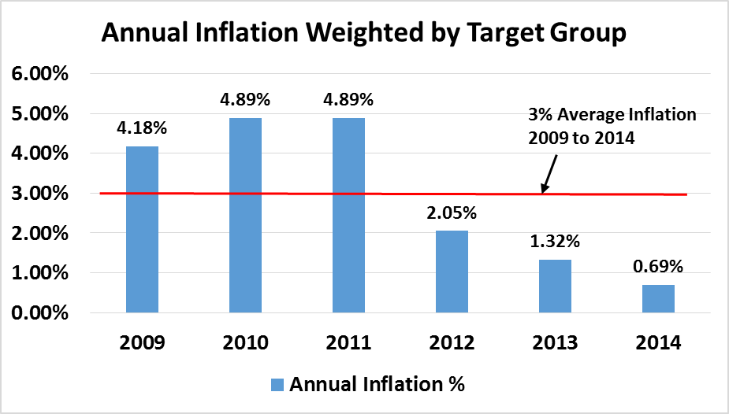

The Family Care Capitation Rate:
The Capitation Rate is a payment made to an MCO each month for each enrolled Member that month. The MCO’s rate is blended and the payment is the same for every Member served in a geographic service region. The payment represents a projected average cost across all MCO Family Care Members and covers all services in the benefit package and administration.
Family Care is not a cost based reimbursement model. We do not receive “dollar for dollar” reimbursement for expenses. The State Department of Health Services only considers MCO expenses when setting capitation rates but also looks at a number of other factors. Other factors considered are whether rate increases to providers have been, in the Department’s determination, too high. When this occurred in the past to both Milwaukee and another MCO, those rate increases were disregarded and not included in the rate setting calculation for a period of three years aft6er they were granted. Lastly, to remain successfully viable, an MCO per member per month cost cannot exceed the Family Care program statewide average cost. Failure to do so will result in an MCO having to access its reserves.
The State Department of Health Services (DHS); the US Centers for Medicaid and Medicare Services (CMS) and the Managed Care Organization all pay a role in developing the rates.
The Responsibilities of DHS are as follows:
- Work with CMS and demonstrate compliance with rate checklist
- Work with MCOs to obtain data, share information, present their analysis, and review contract language
- Contract with an independent actuarial firm to calculate rates. PricewaterhouseCoopers is the current firm and Milliman will take over in 2015.
- Use historical cost data from MCOs for each target group. This data is:
  - Detailed and related to person-specific services and cost information
  - Identified by target group (DD, PD, FE)
  - Reliant on functional status from individual Member assessments using the Long-Term Care Functional Screen (LTCFS) information
  - Based on a statistical model correlates information from two data sources and uses a
    - Statistical/Actuarial approach to calculate average cost. The statistical model identifies:
      - A minimum amount each MCO will get for every Member
      - Certain functional characteristics strongly related to costs above the minimum, and
      - The level of additional cost associated with each functional characteristic ‘add-ons’
      - All current LTCFS data is considered when identifying ‘add-ons’
The Responsibilities of the MCO are as follows:
- Understand the rate setting process and rate setting regulations
- Understand the cost of doing business
- Develop a business plan that supports operating within the funding received
- Supply reliable and timely encounter data to state after providing services to members
- Manage the care of members through
  - Planning and authorizing the appropriate services, person-by-person
  - Identifying and implementing appropriate efficiencies\
The Responsibilities of CMS are as follows:
- Establish the general regulatory framework
- Have a policy checklist to guide states
- Approve rates submitted by the State
- Contribute to funding the rate

Cost and Risk:
The MCO assumes the risk that their revenues will exceed costs of services. Unlike traditional “Fee For Service” plans, risk-based Managed Care is subject to extensive federal statutory and regulatory requirements regarding access to care, quality, collection of encounter data, beneficiary protection, and oversight.

An MCO’s Capitation Rate is calculated as the minimum amount for all Members, plus add-on amounts for those Members with characteristics related to add-on. The table below is an example of service cost experience for MCDFC and the percent distribution of members comprising the range of service cost.

Who Manages Risk?
The State sets minimum funding requirements for Working Capital, Restricted Reserves, and Solvency reserves.
The MCO manages risk by employing the following:
- Timely and Accurate Information
- Systems to support member eligibility and levels of care determination
- Service authorizations systems
  - Resource allocation and care management teams
    - Information and tools to understand service need (RAD)
    - Information and tools to understand actual service utilization and cost

Solvency Protection in Family Care
The Family Care Reserves are akin to the County’s Contingency Reserves. The Milwaukee County Board of Supervisors has made a conscious decision to keep with recommendations from the nonpartisan Public Policy Forum and the independently elected Milwaukee County Comptroller and increase the contingency fund in case of unanticipated emergencies.
It is those same unanticipated emergencies for which the Department of Family Care maintains its reserves. It should be noted that the effect of tapping the reserves is more than financial. In order to utilize reserves, the MCO must deficit. Just as there is a limit on how much or how often the County could deficit without negatively impacting its bond rating, the MCO would similarly negatively impact its contract with DHS and its permit from OCI by repeatedly deficiting in order to access reserves.
The alternative would be to decrease services to other members and/or lower reimbursements to other providers. Neither of those options provide a sustainable business model for MCDFC nor are they in the best interests of members.

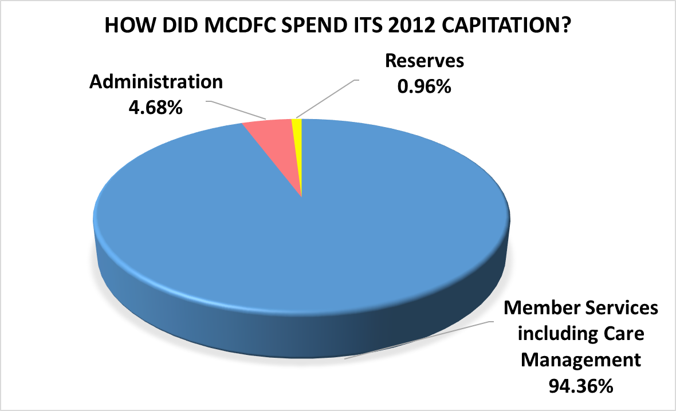
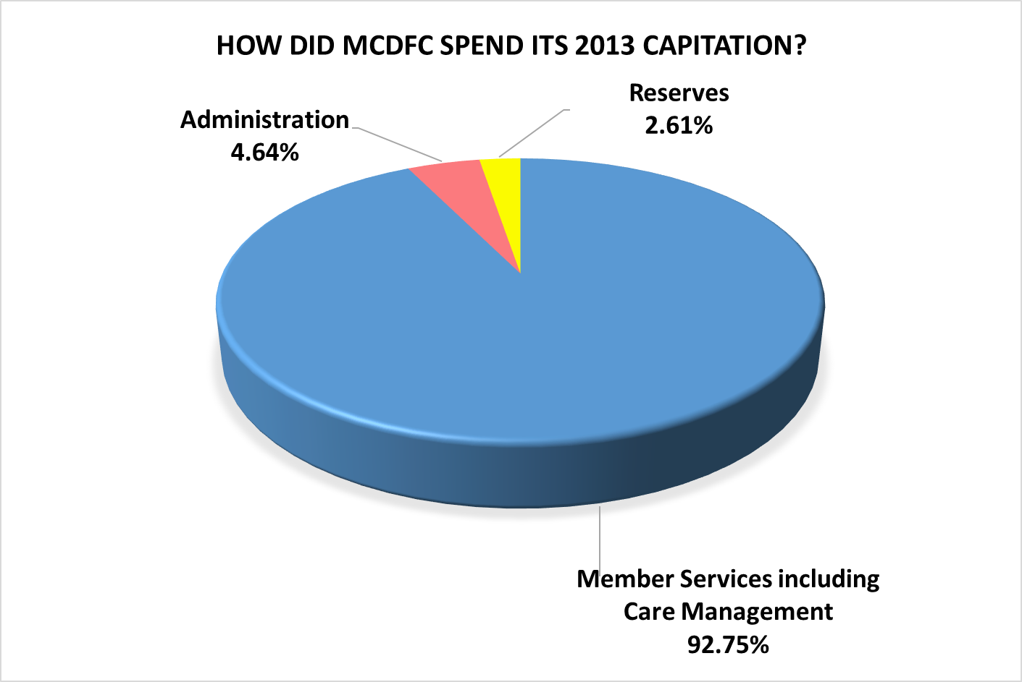

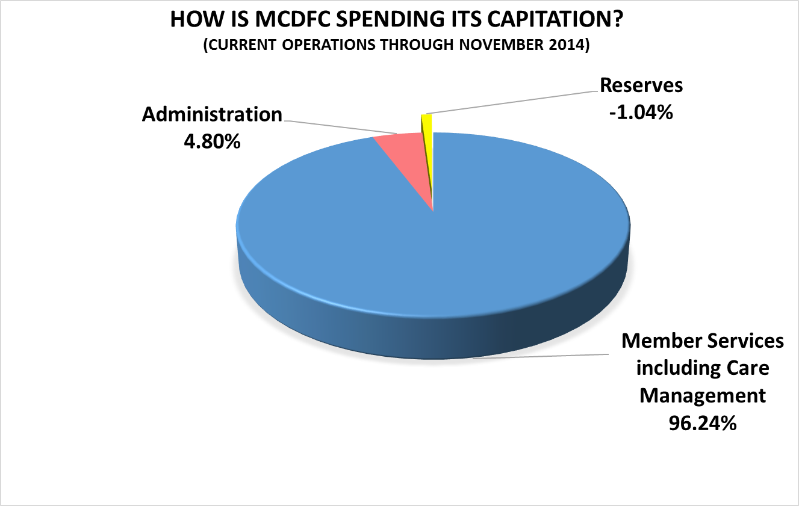
The Department of Health Services employs a layered approach to solvency consisting of
    - Working capital
    - Risk reserve
    - Solvency
Working Capital provides liquid assets to manage routine fluctuations in revenues and expenses that will occur in normal course of business and is equal to the current assets minus current liabilities. It is calculated by MCO and agreed to by State. The minimum requirement equals 3.0% of budgeted annual capitation.
The Restricted Reserves are for the continuity of care for enrolled members, accountability to taxpayers, and effective program administration. They provide additional liquid assets to underwrite financial volatility due to extraordinary circumstances. The Restricted Reserves are held in a separate, identifiable restricted investment reserve account. The required amount is calculated on budgeted annual capitation revenue
The Solvency Reserve is intended to provide continuity of care/transition for Members should the MCO become insolvent. The Assets must be immediately liquid and must equal $750,000 to be held in an account designated by the State.
There is no correlation between the Reserves and the Living Wage Ordinance. Restricted Reserves are intended for one time only extraordinary events. They are not intended to be used for ongoing service costs.
If the Department exhausts its working capital reserve the Department will be placed on corrective action to operationally correct the deficiency. If the Department exhausts their working capital and restricted reserves, it is likely that the State will terminate Milwaukee County’s contract for Family Care and access the pooled solvency reserve to pay remaining expenses of the Department. Two other MCOs have had their contracts terminated in as many years due to lack of solvency.
Termination of our contract to operate an MCO will have an immediate impact on the more than 80 Department of Family Care employees and the nearly 500 community care managers and nurses who comprise our Interdisciplinary Teams. The MCO has care management contracts with 18 community agencies who can serve members who speak only Spanish, Laotian, Hmong or Russian, members who communicate though American Sign Language, members with severe behavior challenges and so on. Milwaukee is the only MCO that contracts with community agencies for care management so if this MCO dissolves and MCDFC members are transferred to another MCO, it is unlikely that any other organization will contract with our community care management partners. The list of community care management partners is attached as Attachment B.
If the State terminates our Family Care contract, our members will enroll with another MCO in Milwaukee County or in IRIS. Neither entity will be under any obligation to pay in home care workers any more than the Federal minimum wage.
There are many exceptions to the Living Wage ordinance. However, the resolution as proposed by Supervisor Johnson does not seek to exempt the Department of Family Care from the Living Wage Ordinance. It seeks only to modify the annual increase so that the Department of Family Care may continue to raise wages, as it has for the past four years, in a manner which does not jeopardize the sustainability of the program nor the health and safety of its members.

Cc: Chris Abele, County Executive
Raisa Koltun, Chief of Staff, Office of the County Executive
Mathew Fortmann, Fiscal & Management Analyst, DAS
Molly Pahl, Budget and Management Coordinator, Office of the Comptroller
Erica Hayden, Research and Policy Analyst, Office of the Comptroller
Steve Cady, Research and Policy Director, Office of the Comptroller
Janelle Jensen, Senior Committee Coordinator, Office of the Milwaukee County Clerk
Jim Hodson, Chief Financial Officer, MCDFC

Attachment A

Items Covered in the Family Care Benefit Package
- Adaptive Aids (general and vehicle)
- Adult Day Care
- Alcohol and Other Drug Abuse Day Treatment Services (in all settings except hospital-based)
- Alcohol and Other Drug Abuse Services (except those provided by a physician or on an inpatient basis)
- Care/Case Management (including assessment and care planning)
- Communication Aids/Interpreter Services
- Community Support Program
- Consumer-Directed Supports/Self-Directed Supports
- Consumer Education and Training
- Counseling and Therapeutic Resources
- Daily Living Skills Training
- Day Services/Treatment
- Durable Medical Equipment (except for hearing aids and prosthetics)
- Financial Management Services
- Home Health
- Home Modifications
- Housing Counseling
- Meals: home delivered
- Medical Supplies
- Mental Health Day Treatment Services (in all settings)
- Mental Health Services (except those provided by a physician or on an inpatient basis)
- Non-Emergency Medical Transportation (except ambulance)
- Nursing Facility (all stays) including Intermediate Care Facility for Individuals with Intellectual Disabilities (ICF/IID) and for people under age 21 or 65 and older in an Institution for Mental Disease (IMD)
- Nursing Services (including respiratory care, intermittent and private duty nursing)
- Occupational Therapy (in all settings except for inpatient hospital)
- Personal Care
- Personal Emergency Response System Services
- Physical Therapy (in all settings except for inpatient hospital)
- Prevocational Services
- Relocation Services
- Residential Services:
  - Adult Family Home (AFH)
  - Certified Residential Care Apartment Complex (RCAC)
  - Community-Based Residential Facility (CBRF)
- Respite Care (for care givers and members in non-institutional and institutional settings)
- Specialized Medical Equipment and Supplies
- Speech and Language Pathology Services (in all settings except for inpatient hospital)
- Specialized Transportation
- Supported Employment
- Supportive Home Care
- Vocational Futures Planning

Attachment B

MCDFC Care Management Partners

ANEW Home Health Service
7400 Harwood Avenue
Wauwatosa, WI 53213

ANS Home Service Inc.
1551 South 108th Street
Milwaukee, WI 53214

Aurora Health Care
3200 W. Highland Avenue
Milwaukee, WI 53208

Carefinders, Inc.
601 E. Henry Clay
Whitefish Bay, WI 53217

Curative
1000 N. 92nd Street
Milwaukee, WI 53226

Easter Seals, Inc.
2222 S. 114th Street,
West Allis, WI 53227

Goodwill
6055 N 91st St
Milwaukee, WI 53225

Horizon
11400 W. Lake Park Drive
Milwaukee, WI 53224-3035

Interfaith
600 W. Virginia
Milwaukee, WI 53204

Jewish Family Services
1300 N. Jackson
Milwaukee, WI 53202

Life Navigators (formerly ARC)
7203 W Center St
Milwaukee, WI 53210-1126

MCFI
2020 West Wells Street
Milwaukee, WI 53233

Metro Home Health Services, Inc.
6014 W. Congress
Milwaukee, WI 53218

Milwaukee Christian Center
807 S. 14th St.
Milwaukee, WI 53204

Project Access
823 S. 60 Street
Milwaukee, WI 53214

S.E.T. Ministry
2977 N. 50th Street
Milwaukee, WI 53210

Temps Plus
1410 E. Capitol Dr.
Milwaukee, WI 53211

United Community Center
1028 South 9th Street
Milwaukee, WI 53204

