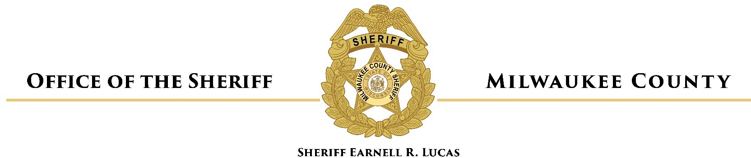

Communication to the Board of Supervisors

DATE: August 12, 2022

TO: Marcelia Nicholson, Chairwoman, Milwaukee County Board of Supervisor

FROM: Denita R. Ball, Chief Deputy, Milwaukee County Sheriff’s Office

RE: In-Person Visitation Restoration Study Informational Report

In Resolution 22-432, the Board of Supervisors requested that the House of Correction and Office of the Sheriff study restoring visitation at the House of Correction (HOC) and Milwaukee County Jail/Criminal Justice Facility (CJF) and to report back no later than the September 2022 meeting cycle.

Information to be provided

- Operational and fiscal estimates and potential grant sources relating to the requirements of resumption of in-person visitation at the House of Correction and Jail/CJF
- The potential operational benefits of in-person visitation
- What neighboring jurisdictions, peer institutions across the United States, and neighboring metropolitan areas are doing relating to visitation and video calling generally and in response to COVID-19.

Background

Prior to 2002, the Milwaukee County Jail facility was equipped for and provided in-person visits for residents housed at the Jail. Visitation areas are located in the center of the building, providing between 2 and 5 visiting booths for each pod. Prior to video visitation, these pods utilized intercom or telephone audio to allow visitors to communicate with loved ones through security glass. In 2002, a study of security at the MCJ recommended video calling as a method of enhancing security. As video and teleconferencing technologies continued to advance, the MCSO turned its focus to video visitation in an effort to increase visitation access for those families who were not able to physically visit at the jail facility. Video visitation was first implemented in the Jail in 2004 through capital project WC021. At this point, in person visitation ended at the Jail facility and the public-facing areas of the MCJ were closed. A video-visitation area
was established on the ground floor of the MCJ which allowed those families without reliable access to internet or technology services to visit their loved ones using visitation stations supplied by the County and its vendor partners. Under this system and prior to COVID-19, the public could go to the MCJ to video call a resident, or remotely video call from anywhere in the world for a fee.

Milwaukee County Sheriff’s Office Status Update
- In-person visitation has not been operational at the Milwaukee County Jail since prior to 2002 and would need restoration of the visitation areas to meet current construction, safety and security standards. The cost of the restoration is unknown at this time and requires additional investigation.
- No funding was allotted for this study so, on July 15, 2022, RFI-2022-002 Milwaukee County Jail In-Person Visitation Feasibility Analysis was posted and is due to close on August 12, 2022.
- Results from the RFI are not available by the due date of the informational report for the September cycle. MCSO will submit a revised report of its findings.

