By Supervisor Lipscomb, Sr. File No. 19-409

A RESOLUTION

Consistent with the will of the people from the November 2018 Advisory Referendum relating to the legalization, regulation, and taxation of marijuana, and in support of the Governor of Wisconsin’s proposals to legalize medical marijuana, decriminalize possession of small amounts of marijuana for personal use, establish an expungement procedure for individuals who have completed their sentence or probation for possession, and align Wisconsin’s laws on cannabidiol (CBD oil) with federal standards

WHEREAS, in File No. 18-760, adopted November 1, 2018, the Milwaukee County Board of Supervisors adopted a resolution encouraging the state of Wisconsin to retroactively decriminalize marijuana; and

WHEREAS, in an advisory referendum during the November 2018 General Election, approximately 70 percent of Milwaukee County voters affirmed the question, “Do you favor adults 21 years of age and older to engage in the personal use of marijuana, while also regulating commercial marijuana-related activities, and imposing a tax on the sale of marijuana?” (File No. 18-333); and

WHEREAS, across Wisconsin during the November 2018 General Election, 16 counties and a city had firm majorities supporting some form of marijuana legalization or decriminalization, including:

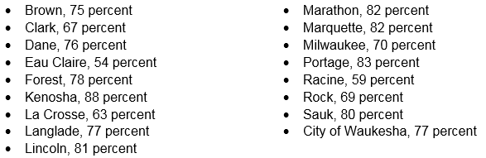

; and

WHEREAS, on February 18, 2019, the Governor of Wisconsin proposed matching federal standards regarding cannabidiol (CBD) oil, legalizing medical marijuana, decriminalizing possession of small amounts of marijuana for personal use, and expunging the criminal records of those convicted and/or on probation for marijuana possession in the 2019-2021 Wisconsin Biennial Budget; and

WHEREAS, in 2019, 33 states, 4 US territories, and the District of Columbia have legalized marijuana for medical and/or recreational use; and

WHEREAS, Milwaukee County should recognize the will of the people as expressed by the November 2018 advisory referendum on marijuana legalization, regulation, and taxation, and Milwaukee County should support statewide proposals which reflect the essence of the voter’s views; now, therefore,

BE IT RESOLVED, consistent with the will of Milwaukee County voters, who advised policymakers in November 2018 by answering affirmatively to the question:

“Do you favor allowing adults 21 years of age and older to engage in the personal use of marijuana, while also regulating commercial marijuana-related activities, and imposing a tax on the sale of marijuana?”

The Milwaukee County Board of Supervisors hereby supports efforts to effectuate the referendum results, which includes the support of the Governor of Wisconsin’s proposals to:

- Legalize medical marijuana
- Decriminalize possession of small amounts of marijuana for personal use
- Establish an expungement procedure for individuals who have completed their sentence or probation for possession
- Align Wisconsin’s laws on cannabidiol (CBD oil) with federal standards

; and

BE IT FURTHER RESOLVED, the Office of Government Affairs staff is authorized and requested to communicate the contents of this resolution to the Wisconsin legislature and the Wisconsin Governor.

