Date: November 17, 2016

To: Theodore Lipscomb, Sr., Chairman, County Board of Supervisors

From: John Dargle, Jr., CPRP, Director, Department of Parks, Recreation and Culture (DPRC)

Subject: Retroactive Extension for a Temporary Assignment to a Higher Classification (TAHC) for Michael Nowakowski – ACTION

POLICY
Chapter 17.085 of the Milwaukee County Code of General Ordinances requires that an extension of temporary assignment beyond 180 days be approved by the Milwaukee County Board of Supervisors.

BACKGROUND
The DPRC requests the continued extension of Michael Nowakowski’s TAHC to the position of Park Maintenance Worker 2 In-Charge from October 14 through December 31, 2016 or until the employee in the position returns from medical leave, whichever occurs first. The previous extension request was for the period of July 23, 2016 through October 13, 2016.

The DPRC anticipates that the employee holding the position will be released from medical leave by the end of the year.

RECOMMENDATION
The DPRC recommends a retroactive extension of the TAHC to a Higher Classification of Michael Nowakowski.

Prepared by: Jen Francis, Chief of Administration & External Affairs

Approved by:
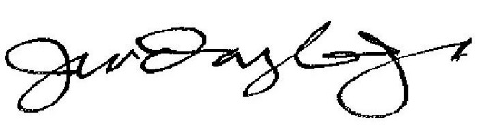

________________________________
John Dargle, Jr., CPRP, Director

Copy: Chris Abele, County Executive
Raisa Koltun, Chief of Staff, County Executive’s Office
Peggy West, Chair, Finance and Audit Committee
Kelly Bablitch, Chief of Staff, County Board
Sheldon A. Wasserman, Vice Chair, Finance and Audit Committee
Jeremy Lucas, Fiscal Mgt. Analyst, Admin & Fiscal Affairs/DAS
Janelle Jensen, Committee Coordinator, Office of the County Clerk
Steve Cady, Research Services Director, Office of the Comptroller
Michael Blickhahn, HRIS Director, Department of Human Resources

