COUNTY OF MILWAUKEE

INTEROFFICE COMMUNICATION

DATE : January 26, 2017

TO : Peggy West, Chair, Finance Committee, County Board of Supervisors

FROM : Steven Kreklow, Director, Office of Performance, Strategy and Budget,

Department of Administrative Services

SUBJECT : 2018 Estimated Budget Gap

OVERVIEW

In the interest of enhancing communication with the County Board and providing budget information at the earliest opportunity, this report provides a preliminary 2018 budget gap estimate as well as the timeline for the upcoming budget process.

BACKGROUND

In recent years, the County has made significant progress in reducing its structural budget deficit. As the chart below illustrates the 2011 Five-Year Forecast projected a 2018 budget gap of over $100 million dollars. Through efficiency improvements and increases in revenues, the County has closed that gap dramatically. However a significant structural budget deficit that requires sustained effort by County leadership persists.

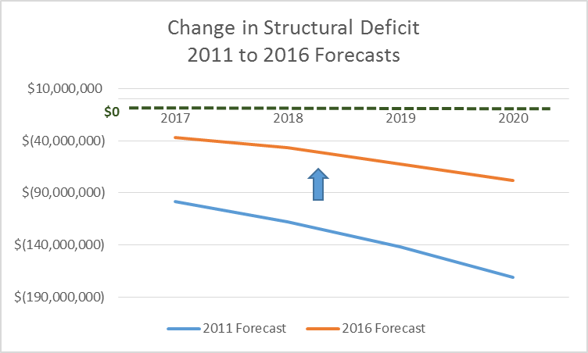

ANALYSIS

Based on preliminary estimates, the County will be facing a 2018 budget gap between $37.5 and $54.7 assuming no significant changes in service levels. This estimated budget gap is larger than the $36.9 million gap addressed during the 2017 budget and presents a major challenge to the County.

The Projected 2018 Budget Gap Breakdown is as follows:

Expenditure Item
Optimistic Gap
Pessimistic Gap
Comptroller Cost to Continue
$12,453,261
$12,453,261
Debt Service Reserve
$10,500,000
$10,500,000
Pension Obligation Bond
$1,500,000
$1,500,000
Employee Pension Contribution
$8,000,000
$8,000,000
Healthcare
$3,000,000
$4,000,000
Compensation Increase
$3,000,000
$3,000,000
State Budget Changes
$0
$3,000,000
Unclaimed Money
$1,250,000
$1,250,000
MCTS Fuel Price Changes
$0
$5,000,000
Revenue Item
GO Pass Revenue
($1,000,000)
$0
Full year VRF
($400,000)
$1,000,000
Sales Tax
($300,000)
$0
Property Tax Levy
($3,500,000)
$0
2016 Surplus
$3,000,000
$5,000,000
Gap Total
$37,503,261
$54,703,261

The paragraphs that follow provide additional information regarding the assumptions used to develop the estimated gap. Please note, the numbers presented here are based on the Comptroller’s 5-year forecast, and any estimated changes for the 2018 budget, therefore they are subject to variability as the budget process continues.

Comptroller Cost to Continue: this number is quoted directly from the Comptroller’s 5-year forecast as an estimate at what departments will need (including personnel costs) for their cost of continue including inflation.

Debt Service Reserve (DSR) and POB Reserve: Higher levels of reserves were used in the 2016 and 2017 budgets to help County absorb increases in pension contributions.

Employee Pension Contribution: Increases in the County’s pension contribution forecasted at $8 million beyond historical trends will occur in 2018 as the investment return assumption is lowered from 8% to 7.75%.
Healthcare: After several years of low employee healthcare costs the expectation is for these costs to return to historically average levels.

Compensation Increase: An increase is projected in compensation for 2018 due to the County’s need to address internal equity and wage disparity issues.

State budget changes: This figure is a best estimate based on current information available about the State of Wisconsin’s upcoming biennial budget process.

Unclaimed Money: Every other year the County Treasurer advertises the possession of unclaimed funds. The budgeted revenue of $1.25 million will not be realized in 2018 but will appear again in 2019.

Fuel Price Increase: The Milwaukee County Transit System (MCTS) has processes in place to reduce risk of significant fluctuations in gasoline prices. Oil prices have been historically low allowing for savings in fuel costs for buses, but any increases would result in an increased expenditure gap for MCTS.

GO Pass Revenue: Revenue is expected to be recaptured beginning in 2018 from the card issuance costs and the $1 per day fare for pass holders.

Full year VRF Collection: Additional revenue from 12 months of collecting the County VRF is expected to offset additional MCTS shortfalls with additional revenue beyond the gap forecasted at $400k.

Sales tax: Sales tax received is expected to grow at CPI in 2017 and 2018 for an additional $500k in 2018.

Property Tax Levy: Forecasting additional revenue due to the County’s assessed valuation increasing again from estimated $1 billion in net new construction.

2016 Surplus: Any unanticipated residual funds at the end of the fiscal year are by state statute applied towards the next subsequent budget year. The surplus at the end of 2016 is expected to be $3 million to $5 million less than the surplus applied to the 2017 budget.

NEXT STEPS: 2018 Budget Process

Resolving the 2018 budget gap will be done through the 2018 budget process which takes place through the following timeline:

- January – Presentation of Budget Gap to County Board
- February-March – Preliminary planning with departments
- April-June – Departments develop their budget requests
- July – Departments submit their budget requests to the Office of Performance, Strategy, and Budget
- August-September – County Executive works with DAS-PSB and departments to finalize the County Executive Recommended Budget
- October-November – The Finance and Audit Committee reviews and requests information on the Recommended Budget
- November – The County Board adopts the 2018 budget
- December – DAS-PSB and the Comptroller’s Office work to implement the 2018 budget.

If you have any questions or would like additional information, please let me know.

RECOMMENDATION
This report is for information purposes only. No action is required.

_________________________
Steven R. Kreklow, Director
Office of Performance, Strategy and Budget
Department of Administrative Services

Cc: Chris Abele, Milwaukee County Executive
Sheldon Wasserman, Co-chair, Finance Committee
Supreme Moore-Omokunde, County Supervisor
Michael Mayo Sr., County Supervisor
Willie Johnson, County Supervisor
Jason Haas, County Supervisor
Sequanna Taylor, County Supervisor
Scott Manske, County Comptroller
Teig Whaley-Smith, DAS Director
Raisa Koltun, Chief of Staff, Office of the County Executive
Kelly Bablitch, Chief of Staff, County Board

