COUNTY OF MILWAUKEE
INTEROFFICE COMMUNICATION

Date: May 10, 2016

To: Supervisor Michael Mayo, Chairman, Transportation, Public Works, & Transit Committee

From: Vince Masterson, Capital Budget Coordinator, Office of Performance, Strategy, & Budget, Department of Administrative Services

Subject: Referral from Annual Capital Budget Process and Workflow

Issue
Pursuant to Supervisor Mayo’s referral request at the May 3, 2016 Transportation, Public Works, & Transit Committee agenda set meeting, please see the attached information regarding the annual capital budget process and workflow.

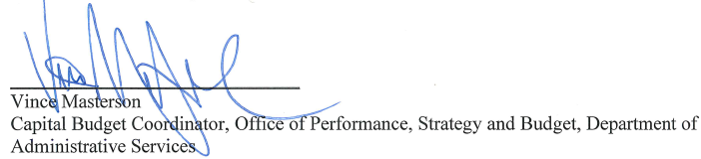

Attachment

