MCTS Opens Registration for Second Annual Transit Teen Advisory Board Program
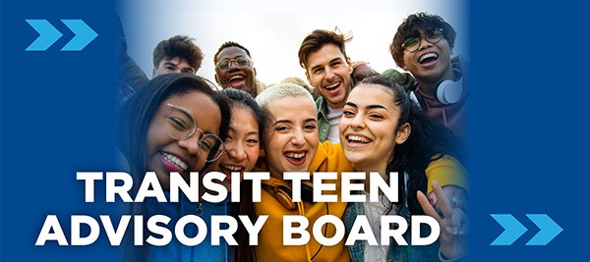
Milwaukee County Transit System (MCTS) is seeking up to 22 community-minded teens between the ages of 14-18 who live in Milwaukee County for the second annual Transit Teen Advisory Board Program. We are looking for teens who are passionate about serving their community, excited by and want to learn more about public transportation, and who have an interest in advocating for their peers. Teens will also engage in interactive educational sessions designed to develop their leadership skills with local leaders throughout Milwaukee County and host an end-of-the-year community event. The term begins on Wednesday, November 15, 2023, and runs through June 2024; the Board will meet every third Wednesday of the month after school at the MCTS Administration Building. Our goal is to develop the capacity of teenage residents to engage, participate and provide perspective on riding the bus and help develop civic engagement.
Eligibility:
- Must live in Milwaukee County
- Be between the ages of 14 and 18

Member Benefits:
- Participate in MCTS events and activities
- Mentorship and networking opportunities
- Receive a Certificate of Participation
- Civic engagement and leadership development
- Receive a $25 monthly meeting stipend
- Receive a free MCTS WisGo bus card

Application:
Click here to fill out the online application form. Deadline to apply is Friday, October 20, 2023. Please email any questions to Biltu Hamda at bhamda@mcts.org

