From the Director of the Office of Strategy, Budget and Performance, requesting authorization to process administrative appropriation transfers which are intended to offset a projected budget deficit in 2024:

A RESOLUTION

WHEREAS, at the Committee on Finance meeting on July 25th, 2024, the Office of the Comptroller shared an updated fiscal projection which included a potential deficit in the range of $17 to $19 million; now, therefore,

WHEREAS, the projected deficit is caused by a reduction in sales tax revenues, increased in health care expenditures, overtime spending deficits in the Office of the Sheriff and the Community Reintegration Center, as well as other departmental projections; and

WHEREAS, the Office of Strategy, Budget and Performance has worked with County departments to identify options to offset the projected deficit; and

WHEREAS, Milwaukee County received an allocation of $183.7 million in American Rescue Plan Act – State and Local Fiscal Recovery Funds (ARPA SLFRF), and a portion of these funds are being proposed for reallocation; and

WHEREAS, Milwaukee County received a supplemental ARPA Local Assistance and Tribal Consistency Fund (LACTF) allocation of $100,000, and these funds have not yet been allocated; and

WHEREAS, the Milwaukee County Transit System received $83 million in dedicated ARPA funding to support the Transit system (separate from the County’s ARPA SLFRF allocation), of which $23 million is projected to remain available at the end of 2024; and

WHEREAS, the Office of the Sheriff is projected to be in deficit by approximately $8 million and an external consultant study is recommended to be performed to identify operational improvements, and to gather baseline data regarding Sheriff Office staffing needs; and

BE IT RESOLVED, the Milwaukee County Board of Supervisors hereby authorizes the Office of the Office of Strategy, Budget and Performance and the Office of the Comptroller to process administrative appropriation transfers to reduce the following tax levy allocations in the amount of up to $9,054,469 (with corresponding reductions in expenditure authority); and

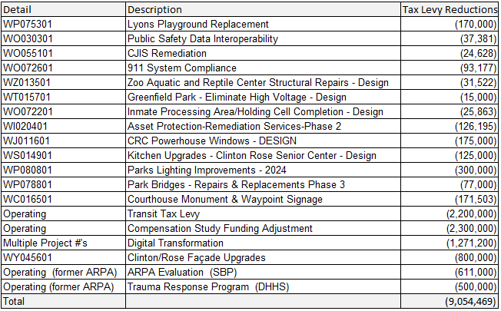

BE IT FURTHER RESOLVED, the Milwaukee County Board of Supervisors hereby authorizes the Office of Strategy, Budget, and Performance and the Office of the Comptroller to process an administrative appropriation transfer to move the above referenced tax levy reductions to increase operating departmental allocations by up to $9,054,469 as appropriate to offset projected deficits in 2024; and

BE IT FURTHER RESOLVED, the Milwaukee County Board of Supervisors hereby authorizes the Office of Strategy, Budget, and Performance and the Office of the Comptroller to process an administrative appropriation transfer to increase federal American Rescue Plan Act funds (and expenditure authority) dedicated to Transit operating budget by $2,200,000; and

BE IT FURTHER RESOLVED, the Milwaukee County Board of Supervisors hereby authorizes the Office of Strategy, Budget, and Performance and the Office of the Comptroller to process an administrative appropriation transfer to increase the debt service reserve contribution (in Agency 996, Org 9960) to pay for debt expenses by up to $5,226,866, and relocate an equal amount of funds (freed up by the increase in debt service reserve contribution) to departmental or non-departmental orgs as needed to offset projected deficits in 2024; and

BE IT FURTHER RESOLVED, the Milwaukee County Board of Supervisors hereby authorizes the Office of Strategy, Budget, and Performance and the Office of the Comptroller to process an administrative appropriation transfer to receive and recognize $100,000 of ARPA Local Assistance and Tribal Consistency Fund (LATCF) revenue, and to allocate $100,000 of expenditures to fund increased Public Safety operational expenditures that are contributing to the current 2024 deficit projection; and

BE IT FURTHER RESOLVED, the Milwaukee County Board of Supervisors hereby authorizes the Office of Strategy, Budget, and Performance and the Office of the Comptroller process an administrative appropriation transfer to reduce the following American Rescue Plan Act State and Local Fiscal Recovery Fund allocations by up to $3,362,655 (with corresponding reductions in expenditure authority); and

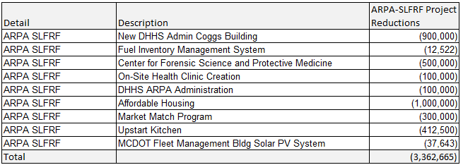

BE IT FURTHER RESOLVED, the Milwaukee County Board of Supervisors hereby authorizes the Office of Strategy, Budget, and Performance and the Office of the Comptroller to process an administrative appropriation transfer to reallocate up to $3,362,655 of American Rescue Plan Act State and Local Fiscal Recovery Funds (and expenditure authority) to support Public Health and Safety Operational expenditures, or other operational expenditures which are eligible for ARPA SLFRF reimbursement; and

BE IT FURTHER RESOLVED, the Milwaukee County Board of Supervisors authorizes the Office of Strategy, Budget, and Performance and the Office of the Comptroller to process an administrative appropriation transfer to reallocate $300,000 of tax levy and increase operating budget authority in the Office of the Sheriff for a study of Sheriff operations to be performed by an external contractor with expertise in operational consulting for municipal law enforcement agencies, to evaluate organizational needs and maximize performance.

